Villa of Hope School

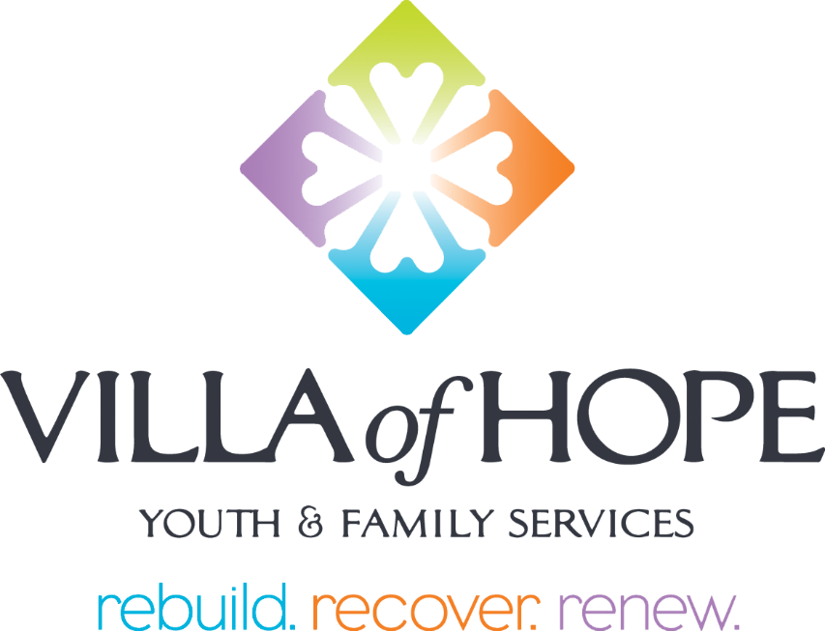

School Code of Conduct

- Be Respectful
- Be Responsible
- Be Safe

*Please be advised that this code of conduct applies to the school-building only. Policies and practices may be different in each of the agency residences.
Updated June 2026
Villa of Hope School - Code of Conduct
Table of Contents

Positive School Climate and Culture 3
Student Rights & Responsibilities 4
Prohibited Student Conduct 5-7
Partnering Together 8-10
Procedures, Policies and Expectations 11-23

Enforcement 13

Disciplinary Action 14
Penalties 14
Consequences and Partnering with Outside Stakeholders………………………………15-16
Rights of Appeal 16
Corporal Punishment 16
Discipline Procedures for Students with Disabilities 16-17
Visitors to the School 18
Protect All Students Act/Jack Reid Law 20-22
Dissemination and Review 23

Appendices………………………………………………………………………………….24-27

Appendix A “School-Wide Behavior Expectation Matrix”…………………………….24

Appendix B “Dress Code”………………………………………………………………25-26

Appendix C “Student Technology and Device Acceptable Use Agreement”……………..27

POSITIVE SCHOOL CLIMATE & CULTURE
Villa of Hope School uses a Multi-Tiered System of Support (MTSS) through Positive Behavior Interventions and Support (PBIS) to promote student success and an overall positive school climate and culture.

MTSS/PBIS is a proactive, preventative, and strengths-based framework that integrates data and instruction to support students’ academic, behavioral, social, emotional, and mental health. It includes four essential components—screening, progress monitoring, a multi-level system of prevention, and data-based decision making. As students demonstrate a need for additional help, supports increase in intensity to match their response to earlier interventions. When implemented with fidelity, this tiered approach improves social-emotional competence, academic success, and overall school climate by creating positive, predictable, equitable, and safe learning environments where all students can thrive.

Tier 1 Primary Prevention or “Universal” Supports are provided to all students.
Tier 1 includes:
- Behavioral Expectations – “Be Safe, Be Respectful, Be Responsible” (Appendix A)
- Behavioral and Social/Emotional Lesson Plans
- School-Wide Token Economy – an acknowledgement system for reinforcing positive student behavior and efforts
- Mild Classroom Based Consequences - emphasize staying in class and responding with a trauma-informed perspective that seeks to understand the student experience.

Tier 2 Secondary Prevention Supports are provided to students who need additional support from Tier 1.
Tier 2 includes, not limited to:
- Check In/Check Out (CICO) – attendance, academic, or behavior
- Small Groups
- Restorative Practices

Tier 3 Tertiary Prevention Supports are provided to individual students who need additional support from Tiers 1 and 2. These are highly individualized plans, developed collaboratively with the student and the parent/guardian. These interventions are documented to track progress.

STUDENT RIGHTS AND RESPONSIBILITIES
Villa of Hope School is committed to safeguarding the rights of all students; and to promote a safe, healthy, orderly and civil school environment.
Villa of Hope School’ Student Bill of Rights and Responsibilities
Rights | Responsibilities
To attend Villa of Hope  Schools and be granted the opportunity to receive a quality education. | To attend school on time, perform assignments, and strive to do your highest quality work.
To be made aware of Villa of Hope School rules and policies, and to be treated in a manner consistent with these policies when resolving disciplinary matters. | To understand Villa of Hope School Code of Conduct, obey the rules it contains and to be accountable for your actions.
To have the opportunity to present your version of the facts and circumstances in all disciplinary matters. | To be truthful and respectful in the resolution of conflicts with all parties involved.
To take part in all Villa of Hope School activities on an equal basis regardless of race, sex, religion, age, political affiliation, sexual orientation, national origin or disability. | To be respectful and supportive to all who are participating in Villa of Hope School academic and social activities.
To feel safe in the school environment and not be intimidated or harassed by others. | To behave in a manner that will not jeopardize the safety and well-being of yourself or others, and respect and treat others in a fair and equitable manner.
Villa of Hope School’ Student Rights and Responsibilities focus is on promoting positive student behavior and a positive school climate.

PROHIBITED STUDENT CONDUCT
Students are expected to behave with dignity and treat others with respect and courtesy. Villa of Hope School promotes students’ learning to assume and accept responsibility for their own behavior, as well as the consequences of their misbehavior.
The rules of conduct listed below are intended to focus on safety and respect for the rights and property of all students and staff. Students who violate these school rules will be required to accept the consequences for their conduct. Students may be subject to disciplinary action, up to and including suspension from school, when they engage in conduct that is: disorderly/disruptive; insubordinate; violent; endangers the safety, morals, health or welfare of self and others; or is otherwise dishonest, including academic misconduct.
- Conduct that is Disorderly/Disruptive (examples, not inclusive)
- Engaging in any act that disrupts the normal operation of the school community or educational environment. This includes running in hallways; making unreasonable noise; and using language or gestures, including spitting, that are profane, lewd, vulgar, abusive, intimidating, or that incite others.
- Trespassing - Students are not permitted in any area of the school building, other than the one they regularly attend, without approved permission from the students’ team and the administrator or his/her designee in charge of the building.
- Misusing computer/electronic communication devices, including any unauthorized or inappropriate use of computers, software, or internet/intranet account; accessing inappropriate websites; unauthorized use of personal electronic devices/equipment; or any other violations.
- Misconduct on a school bus or agency vehicle.

- Conduct that is Insubordinate
- Failing to comply with the reasonable directions of teachers, teacher assistants, social workers, school support staff, administrators or any other Villa of Hope employees or otherwise demonstrating disrespect.
- Missing or leaving school or class without permission.

- Conduct that is Violent
- Committing, threatening or attempting an act of violence (such as hitting, kicking, punching, spitting, or scratching) upon a student or Villa of Hope employee or any person lawfully on Villa of Hope property, or at a Villa of Hope function.
- Possessing a weapon, displaying what appears to be a weapon, threatening to use any weapon(s) or using weapon(s).
- Intentionally damaging or destroying Villa of Hope property, the personal property of a student or Villa of Hope employee or any person lawfully on Villa of Hope property, or at a Villa of Hope function.
- Communication by any means, including oral, written or electronic (such as through the Internet or e-mail) off school property, where the content of such communication (a) can reasonably be interpreted as a threat to commit an act of violence on school property; or, (b) results in, or can be reasonably forecast to result in, disruption to the educational environment.

- Conduct That Endangers the Safety, Morals, Health or Welfare of Others
- Lying, deceiving, or giving false information to school personnel.
- Stealing Villa of Hope property or the property of other students or staff.
- Making false statements or representations about a person or identifiable group of people that harm the reputation of the person or group by demeaning them (defamation). This can include posting, publishing or disseminating written materials, video, audio recordings or pictures that are defamatory on the Internet or on a cell phone.
- Discrimination, which includes the use of race, age, sexual orientation, creed, national origin, religion, gender or disability as a basis for treating another in a negative manner.
- Harassment, which includes communication (verbal, written, electronic or graphic) and/or physical conduct based on an individual's actual or perceived race, religion, national origin, political affiliation, sexual orientation, gender, age, marital or veteran status or disability.
- Bullying and intimidation, which includes engaging in actions or statements that a reasonable person would interpret as a threat to place an individual in fear of bodily harm and/or emotional discomfort; for example, "play" fighting, extortion of money, overt teasing, etc.
- "Internet bullying" (also referred to as "cyber-bullying") includes the use of instant messaging, e-mail, websites, chat rooms, and text messaging, when such use interferes with the operation of the school; or infringes upon the general health, safety and welfare of students or employees.
- Sexual harassment, which includes unwelcome sexual advances, requests for sexual favors, and other verbal or physical conduct or communication of a sexual nature (including taking, sending or receiving sexually explicit videos, pictures or auditory recordings).
- Displaying overt signs of gang affiliation or engaging in gang-related behaviors that have been observed to increase the level of conflict or violent behavior in the school or when school authorities may reasonably forecast violence or substantial disruption of school activities.
- Hazing, which includes any intentional or reckless act directed against another for the purpose of initiation into, affiliating with or maintaining membership in any school sponsored activity, organization, club or team.
- Selling, using, possessing or distributing obscene/offensive material.
- Possessing, consuming, selling, attempting to sell, distributing or exchanging alcoholic beverages, tobacco, tobacco products or illegal substances, or being under the influence of any of these. "Illegal substances" include, but are not limited to, inhalants, marijuana, cocaine, LSD, PCP, amphetamines, heroin, steroids, look-alike drugs, drug paraphernalia and any substances commonly referred to as "designer drugs."
- Inappropriately using, sharing, selling, attempting to sell, distributing or exchanging prescription and over-the-counter drugs.
- Possessing, consuming, selling, attempting to sell, distributing, or exchanging "look-alike drugs"; or, possessing or consuming (without authorization), selling, attempting to sell, distributing or exchanging other substances such as dietary supplements, weight loss pills, etc.
- Gambling and gaming.
- Inappropriate touching and/or indecent exposure.
- Initiating or reporting warning of fire or other catastrophe without valid cause, misusing 911, or inappropriately discharging a fire extinguisher.
- Academic Misconduct
- Plagiarism
- Cheating
- Copying
- Altering records/forgery
- Assisting another student in any of the above actions

PARTNERING TOGETHER TO BUILD A POSITIVE SCHOOL ENVIRONMENT
The success of Villa of Hope School is dependent on an interdisciplinary team of essential partners working together towards the continued progress of each individual student. These essential partners include the student, family/guardian, district, educational staff, residential staff, clinical staff, and other stakeholders. We encourage parents/guardians to be actively involved in their child’s education. To make lasting progress with each student in our program, active involvement from students’ personal and/or familial involvement is fundamental.
All parents, guardians and those individuals acting in the role of parent or guardian:
    - Recognize that the education of their child is a joint responsibility of the parents/guardians and the school community.
    - Send their child to school ready to participate and learn.
    - Ensure their child attend school regularly and on time.
    - Ensure absences are excused.
    - Encourage their child to be dressed and groomed in a manner consistent with the student dress code and/or safety requirements.
    - Know school rules and help their child understand them.
    - Help their child understand that in a democratic society appropriate rules are required to maintain a safe, orderly environment.
    - Promote positive behavior in their child by helping them to accept the consequences of their actions and by becoming involved in their behavior management/disciplinary process.
    - Convey to their child a supportive attitude toward education and social-emotional development.
    - Build positive relationships with school staff, and other Villa of Hope staff.
    - Help their child deal effectively with peer pressure.
    - Inform school staff of changes in the home situation that may affect student conduct or performance.
    - Be an active participant in meetings regarding their child.

All Teachers are expected to:
- Maintain a climate of respect that supports students’ dignity, strengthens self-concept, and builds confidence in learning.
- Plan engaging instruction that draws on students’ strengths and promotes academic growth.
- Demonstrate care for students by supporting their well-being, monitoring progress, and responding to individual needs.
- Use effective behavior supports, including trauma-informed strategies, TCIS principles, and Sanctuary commitments.
- Communicate clearly with students and families about:
  - Course objectives and requirements
  - Grading procedures
  - Assignment expectations and deadlines
  - Student rights and responsibilities
  - School-wide PBIS expectations
- Maintain regular communication with students, families, and colleagues about progress and achievement.
- Follow the Villa of Hope School Code of Conduct and all school and agency policies.

All related Support Providers and Teacher Assistants are expected to:
- Maintain a climate of respect that supports students’ dignity, strengthens self-concept, and promotes confidence in learning.
- Provide appropriate educational support that help students participate fully in their instructional program.
- Support academic and behavioral goals by reinforcing classroom learning and skill development.
- Assist students with social and emotional needs using trauma-informed strategies, including TCIS, Sanctuary principles, and PBIS practices.
- Know and consistently enforce school policies in a fair, respectful, and supportive manner aligned with the Villa of Hope School Code of Conduct.
- Communicate appropriately with students, families, and staff to support student growth and well-being.
- Follow the Villa of Hope School Code of Conduct and all school and agency policies.

Leadership and Administration are expected to:
- Maintain a climate of respect that upholds students’ dignity, strengthens self-concept, and supports confidence in learning.
- Promote a safe and engaging school environment that supports active teaching, learning, and positive school culture.
- Ensure open communication by providing students, families, and staff opportunities to share concerns and seek resolution.
- Evaluate school programs regularly to ensure effectiveness and continuous improvement.
- Support extracurricular opportunities that encourage student involvement and growth beyond the classroom.
- Enforce the Villa of Hope School Code of Conduct fairly and ensure that all matters are addressed promptly and consistently.
- Apply trauma-informed and MTSS/PBIS-aligned practices by modeling and supporting TCIS techniques, Sanctuary principles, and effective MTSS/PBIS strategies.
- Ensure a school-wide behavior system is in place and supported to meet the needs of all students.
All other Villa of Hope Staff are expected to:
    - Maintain a climate of mutual respect and dignity, which will strengthen students’ self-concept and promote confidence to learn.
    - Recognize Villa of Hope (NYSED) of Rules and Regulations.
    - Support administration or administration designee in decisions made.
    - Perform specialized non-instructional duties that support the operational functioning of school.
    - Know school policies and rules and support the implementation of the Code of Conduct.
    - Adhere to all Villa of Hope policies and procedures.

PROCEDURES, POLICIES, AND EXPECTATIONS

Distraction Free Learning
New York State’s Distraction-Free Schools Law (Education Law 2803) took effect in May 2025. Under the Bell-to-Bell Policy, all personal electronic devices must be off and out of sight from the first bell to the last. The goal is to create focused, connected, distraction-free classrooms that support student success.

Device Expectations
All personal electronic devices must be turned in upon arrival.
All personal devices must be placed in the designated storage container.
Students may not carry any personal electronic device during the school day.
Devices are returned at dismissal.

Prohibited Technology Use
Internet-enabled devices may not be used during the school day.
Cameras are never allowed for any reason.
Violating the Distraction-Free Learning expectations will result in disciplinary action.

Disciplinary Responses (not limited to)
Confiscation of the device
Parent/guardian communication
Additional restorative or corrective measures as needed

Student Technology and Device Acceptable Use Agreement (Appendix C)
Villa of Hope and Villa of Hope School reserve the right to monitor the internet usage of its students and staff to ensure age-appropriateness, school appropriateness, and therapeutic impact.

- Students are expected to use computers and the internet consistent with the age-appropriateness and therapeutic needs of all students.
- Computer and internet usage is not to include violence, drug use, tobacco/alcohol use, weapons, overt sexuality, bodily fluids, or offensive language.
- Computer usage (time and length) is up to the discretion of the classroom staff.
- Students’ computer use must be on a filtered account or must be under direct supervision.

Student Searches
All students are subject to search when entering the building. Every student will walk through the metal detector, be screened with a wand, and searched as needed.
Desks and other such storage spaces remain the exclusive property of the school and students shall have no expectation of privacy with respect to these areas:
- Given reasonable suspicion with concrete, articulable facts that a student has, or is likely to have, violated the law or a school policy, school administration or designee reserves the right to search a student’s person and/or belongings while in attendance at school.
- Searches will always be conducted with two staff members, one being of the same gender as the student subject to search.
- Under no condition will any member of the school participate in a police search, although administration reserves the right to contact law enforcement.

Everyone in our school community helps keep our environment safe and respectful. Students should speak up when they see a problem and share concerns with a trusted adult. Students are expected to cooperate and help when staff look into behavior issues that break the Code of Conduct.
  - An appropriate staff member will resolve the problem immediately by following Villa of Hope School policies and procedures.
  - Referral cases which are not resolved immediately and need further inquiry and/or information, shall be dealt with by an administrator, social worker and the behavioral support team. This inquiry process may include information from students, staff members, parents, and community resources. Resolution of the problem may involve group/team interaction.
  - Where required by law, and under such other circumstances as are deemed appropriate by school authorities, problems involving the breaking of local, state and federal laws shall be reported to the appropriate legal authority.

Dismissal
- Daily student dismissal occurs between 2:45 p.m. and 2:55 p.m.
- Students are called for dismissal when their transportation arrives. They will receive their phone at this time.
- All students are required to depart the campus using district-provided transportation or transportation arranged by a parent/guardian.
- When a student refuses transport, parent/guardian contact will be attempted. If we are unable to reach a caregiver after a reasonable waiting period, emergency services will be contacted.
- Villa of Hope staff have important professional commitments immediately following dismissal, they are not available to supervise students afterward. Thank you for helping us maintain a smooth and timely dismissal process.
- For any ongoing transportation barriers, the school will support collaboration with district and family.

ENFORCEMENT
  - It shall be the duty of the school administrator, behavioral support team or designee to make an initial determination as to whether the conduct of any person violates the policies of Villa of Hope School, rules, or regulations.
  - The person making the initial determination of such a violation may take immediate and appropriate action to abate the violation and, if authorized, may further administer appropriate disciplinary measures at the time such violation is determined. Such individuals may defer a determination of the appropriate disciplinary measures for a reasonable period of time for further investigation and action by building administration.
  - The respective building leadership, or their designees, shall have responsibility for the review of the findings of the alleged violation of these polices and, insofar as authorized by law, shall have the authority to administer appropriate discipline for violations.

DISCIPLINARY ACTION

Violation by Students
A student who has been found in violation of this policy shall be subject to such disciplinary action as set forth under the “Penalties” section below as deemed appropriate under the circumstances. Parent(s)/Guardian(s)/Social Worker/Case Manager/IEP Coordinator/District Representative for Student will be notified either orally or in writing, by the Director of Education or his/her designee, depending on the nature of the violation. It is the policy of the school that disciplinary problems are handled promptly and appropriately by Villa of Hope School representatives most directly concerned, and that building leadership be involved only in more serious disciplinary problems.

Violation by Staff Members
Faculty and staff members found in violation of Villa of Hope policies are subject to dismissal, suspension, termination or other disciplinary actions. Disciplinary action involving faculty and staff members shall be consistent with the provisions of the New York Education Law and New York Civil Service Law.

Violation by a Visitor
Any visitor who is deemed to be in violation of this policy shall be informed of the alleged violation and asked to desist. If necessary, the person may be asked to leave Villa of Hope School property and upon failure to do so, or if otherwise deemed appropriate, law enforcement authorities may be called upon to assist.

The Justice Center will be notified, as required.

CONSEQUENCES AND PARTNERING WITH OUTSIDE STAKEHOLDERS

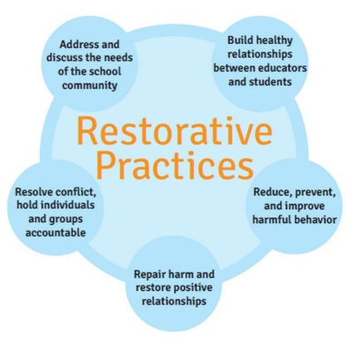
Violation of the Code of Conduct may result in, but not be limited to, verbal warnings, conference with the school administrators or designee, remediation and mediation between affected parties, that may include restorative practices, in-school support room, and/or out-of-school suspension in accordance with NYSED regulations.
Restorative practices help our school build strong relationships and a positive community. When conflicts happen, students are supported in understanding how their actions affected others and in taking steps to repair any harm. Restorative circles, “circle-ups”, give everyone a chance to speak, listen, and learn from one another, helping improve communication, empathy, and trust.
The school will track suspensions per NYSED guidelines and refer to local school districts’ CSE if a change in placement is warranted. Suspension will be conducted consistent with part 200 regulations for individuals with disabilities.
The following disciplinary measures are among those deemed appropriate but not limited to.
The disciplinary measures for students may include one or more of the following activities:
  - Individual appropriate action by teacher, staff or administrator.
  - Parent/Guardian/Social Worker/Behavior Support Specialist/Case Manager for conference-collaborating effort to solve the problem.
  - Removal from a class by a teacher, administrator or behavioral support team.
  - Loss of privileges.
  - Loss of Villa of Hope transportation or social event privileges.
  - Involvement of appropriate legal agencies and actions.
  - Restitution
  - Other

RIGHTS OF APPEAL
The discretion to modify discipline on a case-by-case basis considers the following:
- Age of student
- Prior disciplinary record
- Belief that other forms of discipline may be more effective
- Input from the students’ school team, parent/guardian, or others
- Extenuating circumstances
- Disability classification
Authority for the school conduct and discipline is delegated to the Director of Education. Any individual aggrieved by a finding of violation of this policy, and/or the disciplinary measures resulting therefrom, may appeal to the Chief Compliance Officer.
CORPORAL PUNISHMENT
Corporal punishment is any act of physical force upon a student for the purpose of punishing that student. Corporal punishment of any student by any Villa of Hope School’ employee is strictly forbidden.

DISCIPLINE PROCEDURES FOR STUDENTS WITH DISABILITIES
Villa of Hope School will comply with all state and federal laws regulating discipline procedures for students with disabilities.
The disciplinary procedures for students with disabilities have been developed to:
  - Promote early intervention and avoid escalation of behavioral or other adjustment problems.
  - Examine and respond to behavior as it relates to the disability.
  - Provide for modifications of instructional program, services and/or placement, in an expedited fashion to avoid disruption of the student’s education.

It is intended that behavior which is related to the disability and does not present a serious danger to self or others, should be dealt with through modification of the instructional program, MTSS, behavior intervention plan, services or placement rather than the suspension process. This would include conferences among the students’ school team and parent/guardian, to attempt to resolve the problem.
In situations where the behavior is not related to the disability and/or the behavior does present a serious danger to self or others insofar as situations where alternative procedures and methods that do not involve the use of physical force cannot reasonably be used, Therapeutic Crisis Physical Interventions (TCIS) may be used only to:
    - Protect oneself, another student, teacher or any person from physical injury.
    - Safely remove a student whose behavior interferes with the orderly exercise and performance of Villa of Hope School functions, powers and duties and/or if that student has refused to refrain from further disruptive acts.

These procedures have been developed to avoid prolonged periods of time without any instructional program for students and/or to minimize the staff time involved in the long-term process. (NY State Regulations of the Commissioner of Education Part 200 Students with Disabilities and Part 201 Procedural Safeguards for Students with Disabilities Subject to Discipline).

VISITORS TO THE SCHOOL

The school administrator or his/her designee is responsible for all persons in the building and on the grounds. For these reasons, the following rules apply to visitors to the school:
- All non-staff adults and students on the property of Villa of Hope including, but not limited to, parents, guardians, natural support and siblings, are considered visitors.
- All visitors to the school must report to the office upon arrival through the intercom at door 2/3.
- Visitors will be always escorted and supervised by staff on the premises. No member of the school community will allow visitors into the building who have not identified themselves to the main office first.
- Individuals/students are not to be alone with visitors, while in the school building:
  - Exceptions are made for parent/guardians, CPS, The Justice Center, police, OMH, OCFS, NYSED, county agency and school district representatives.
  - Villa of Hope School reserves the right to require staff attendance even during visits by those listed above.
- Parents/Guardians are asked not to enter the classrooms during the school day without making prior arrangements with the teacher or accompanied by an administrator.
- In order to support the learning of all students and avoid disruption in the classroom, Parents/Guardians are asked to try scheduling meetings with school staff either before or after the school day whenever possible.
- Any unauthorized person on school property will be reported to the administrator in charge or his/her designee, will be asked to leave, and the police may be called if the situation warrants.
- All visitors will abide by the rules for public conduct on school property contained in this Code of Conduct.

Public Conduct on School Property

Villa of Hope and Villa of Hope School are committed to providing an orderly, respectful environment that is conducive to learning. To create and maintain this kind of environment, it is necessary to regulate public conduct on school property and at school functions. For purposes of this section of the Code, “public” shall mean all persons when on school property or attending a school function including students, teachers and agency personnel.

The restrictions on public conduct on school property and at school functions contained in this Code are not intended to limit freedom of speech or peaceful assembly. Villa of Hope recognizes that free inquiry and free expression are indispensable to the objectives of the agency. The purpose of this Code is to maintain public order and prevent abuse of the rights of others.

All persons on school property or attending a school function shall conduct themselves in a courteous, respectful and orderly manner. In addition, all persons on school property will be properly attired.

Prohibited Conduct

No person, either alone or with others, shall violate any federal or state law, or regulation, local ordinance or agency policy while on school property or while at a school function, or:

- Intentionally injuring any person or threatening to do so.
- Intentionally damage or destroy agency property or the personal property of any school employee, agency employee or any person on school property.
- Disrupt the orderly conduct of classes, school programs or other school activities.
- Distribute or wear materials on school grounds or at school functions that are obscene, advocate illegal action, appear libelous, obstruct the rights of others, or are disruptive to the school program.
- Intimidate, harass or discriminate against any person on the basis of race, color, weight, national origin, ethnic group, religion, religious practice, disability, sexual orientation, gender/gender identity, or sex.
- Enter any portion of the school premises without authorization or remain in any building or facility after it is normally closed.
- Obstruct the free movement of any person in any place to which this Code applies.
  - Exception is made for emergency interventions performed by trained agency staff and utilized consistent with NYSED regulations on emergency interventions and documented, reported, and monitored consistent with those regulations.
- Violate the traffic laws, parking regulations or other restrictions on vehicles.
- Possess, consume, sell, distribute or exchange alcoholic beverages, controlled substances, or be under the influence of either on school property or at a school function. In addition, the use of tobacco products is prohibited.
- Possess or use weapons in or on school property or at a school function, except in the case of law enforcement officers or except as specifically authorized by the agency.
- Loiter on or about school property.
- Gamble on school property or at school functions.
- Refuse to comply with any reasonable order of identifiable agency officials performing their duties.
- Willfully incite others to commit any of the acts prohibited by this Code.
- Violate any federal or state law, local ordinance or agency policy while on agency property or while at a school function.

Penalties
Persons who violate this Code of Conduct shall be subject to the following penalties:
- Visitors shall have their authorization, if any, to remain on school grounds or at the school function withdrawn and they shall be directed to leave the premises. If they refuse to leave, they shall be subject to ejection.
- Students shall be subject to disciplinary action as the facts may warrant, in accordance with the due process requirements.
- Staff members shall be subject to warning, reprimand, suspension, or dismissal as the facts may warrant in accordance with any legal rights they may hold.

Enforcement
The Director of Education or his/her designee shall be responsible for enforcing the conduct required by this Code.

When a school administrator or his/her designee see an individual engaged in prohibited conduct, which in his or her judgment does not pose any immediate threat of injury to persons or property, the administrator or his/her designee shall tell the individual that the conduct is prohibited and attempt to persuade the individual to stop. The administrator or his/her designee shall also warn the individual of the consequences for failing to stop. If the person refuses to stop engaging in the prohibited conduct, or if the person’s conduct poses an immediate threat of injury to persons or property, the administrator or his/her designee shall have the individual removed immediately from school property or the school function. If necessary, local law enforcement authorities will be contacted to assist in removing the person.

The agency shall initiate disciplinary action against any student or staff member, as appropriate, with the “Penalties” section above. In addition, the agency reserves its right to pursue civil or criminal legal action against any person violating the code.

Protect All Student Act/Jack Reid Law
Bullying has been described as unwanted, aggressive behavior that involves a real or perceived power imbalance. The behavior is repeated, or has the potential to be repeated, over time. Bullying can occur before and after school hours, in a school building or at locations such as outdoor recreation area or on a school bus while a student is traveling to or from school, or on the Internet. Students who are bullied and those who bully others may potentially have serious and lasting trauma.
Characteristics include:
- An Imbalance of Power: Students who bully others use their power, such as physical strength, access to embarrassing information, or popularity, to control or harm others. Power imbalances can change over time and in different situations, even if they involve the same people.
- The Intent to Cause Harm: Determining the intent of an individual who demonstrates bullying behaviors may be difficult. The perception of the person who is the target of those behaviors should also be considered.
- Repetition: Bullying behaviors generally happen more than once or have the potential to happen more than once.

Examples of bullying include, but are not limited to:
- Verbal: Name-calling, teasing, inappropriate sexual comments, taunting, and threatening to cause harm.
- Social: Spreading rumors about someone, excluding others on purpose, telling other students not to be friends with someone, and embarrassing someone in public.
- Physical: May include hitting, punching, shoving, kicking, pinching, spitting, tripping, pushing and taking or breaking someone’s things.
- Micro-aggressions are brief, everyday exchanges, verbal and non-verbal, that send messages to certain individuals that because of their group membership, they have little worth. These small exclusions, expressions, and gestures are often overlooked as contributing to negative school climate and over time can cause emotional harm.

Prevention
The school setting provides an opportunity to teach students, and emphasizes among staff, that cooperation with, and respect for, others is a key value of Villa of Hope School. The program includes a Code of Conduct that is reinforced for all students and staff. Students may also engage in counseling and speech services designed to facilitate appropriate peer relationships. When a student is identified as being engaged in inappropriate conduct or a potential victim of inappropriate conduct, the level of supervision may be raised. Additionally, positive school-wide support encourages productive and positive interactions between students, staff, and families.

Intervention:

In the event of an actual incident of bullying or harassment, all staff at Villa of Hope School are trained in TCIS interventions to protect all individuals present and preserve safety. Should any physical interventions be required to protect individuals from imminent and significant harm, the family will be notified consistent with Villa of Hope School policy and NYSED regulations.

Reporting and Investigating:

Students who have been subjected to harassment, bullying and/or discrimination, persons in parental relation whose students have been subjected to such behavior, or other students who observe or are told of such behavior, are encouraged and expected to make verbal and/or written reports to school staff, and/or school administrators.

All school staff, when aware of harassment, bullying and/or discrimination, are required to orally report the incident(s) immediately to the Director of Education, or his/her designee, and report it in writing. Depending on the severity of the incident, a referral may need to be completed and submitted, per that procedure, which includes filing the report prior to end of the school day. Staff will take appropriate safety measures and complete the Villa of Hope reporting form. This form will be submitted to the School Counselor.

Complaints shall be documented, tracked, investigated, and remediated in accordance with the regulations and procedures and the school’s Code of Conduct. If a staff person is unsure of the reporting procedure, he or she is expected to inquire about how to proceed by speaking with his/her supervisor.

The results of any such investigation shall be reported to both the targeted student and the alleged offender, as well as their respective persons in parental relation. If either party and/or their respective persons in parental relation disagree with the results of the investigation, that party should be advised that they may contact the Director of Education or Chief Compliance Officer.

In certain circumstances, disclosure to the persons in parental relation on the basis for which a student is harassed, bullied and/or discriminated against may unintentionally result in additional negative consequences to the student’s health and well-being due to the sensitive nature of the subject of bullying. Prior to notification of any person in parental relation regarding an incident of harassment, bullying and/or discrimination, school authorities must consider notification as they would any other educationally relevant decision, taking into account the health, well-being, and safety of students involved in the incident.
To accommodate the above, the Director of Education or designee may seek counsel from the Chief Compliance Officer to determine the best course of action. In some cases, such as where a student is being targeted with anti-LGBTQ+ language, if there is reason to fear that that student may face negative consequences by notifying his/her persons in parental relation, regardless of how she/he actually identifies, this should be taken into account in the decision whether to notify a person in a parental relationship.
Student Disciplinary Consequences/Remediation
The primary focus of this policy is on proactive prevention, when harassment, bullying and/or discrimination occur, student offenders will be given a clear message that their actions are inappropriate, will not be tolerated, and are inconsistent with the concepts of tolerance, respect for others, and the fostering of civility in schools in order to provide a safe and supportive school environment for all students. Student offenders will receive in-school guidance, such as restorative practices, on making positive choices in their relationships with others. If the behavior rises to the level of a criminal act, the school administrator or his /her designee shall contact law enforcement promptly.
The response to a student’s violations of the policy shall be age-appropriate and developmentally appropriate. Consequences, if appropriate, for a student who commits an act or acts of harassment, bullying and/or discrimination shall be unique to the individual incident and shall vary in method and severity according to the nature of the behavior, the developmental age of the student, the student’s previous disciplinary record, other extenuating circumstances, and must be consistent with the school Code of Conduct.

Investigating and Responding to Allegations of Staff-to-Student Harassment, Bullying and/or Discrimination
In the case of a report of alleged staff-to-student bullying: reporting, investigation, and response must follow all applicable school policies and procedures, including immediately contacting the Justice Center and an administrator, and all steps must be taken to immediately provide protections to the student.

Non-Retaliation
Any person having reasonable cause to suspect that a student has been subjected to harassment, bullying and/or discrimination by a student and/or an employee who, acting reasonably and in good faith, either reports such information to school officials, to the Commissioner of Education, referring school district, The Justice Center, or to law enforcement authorities or otherwise initiates, testifies, participates or assists in any formal or informal proceedings, will have immunity from any civil liability that may arise from the making of such a report or from initiating, testifying, participating or assisting in such formal or informal proceedings. Schools and their respective employees are prohibited from taking, requesting or causing retaliatory action against any such person, who, acting reasonably and in good faith, either makes such a report or initiates, testifies, participates or assists in such formal or informal proceedings (Education Law §16).

DISSEMINATION AND REVIEW
Villa of Hope School will work to ensure that the school community is aware of this Code of Conduct by:

- Providing copies of the Code of Conduct to all students.
- Making copies of the Code of Conduct available to all parents/guardians at the beginning of each school year and upon request.
- Provide all staff members with a copy of the Code of Conduct at the beginning of each school year and upon request.

Villa of Hope School will review this Code of Conduct and update it annually as necessary with the input of the school community.

APPENDIX A
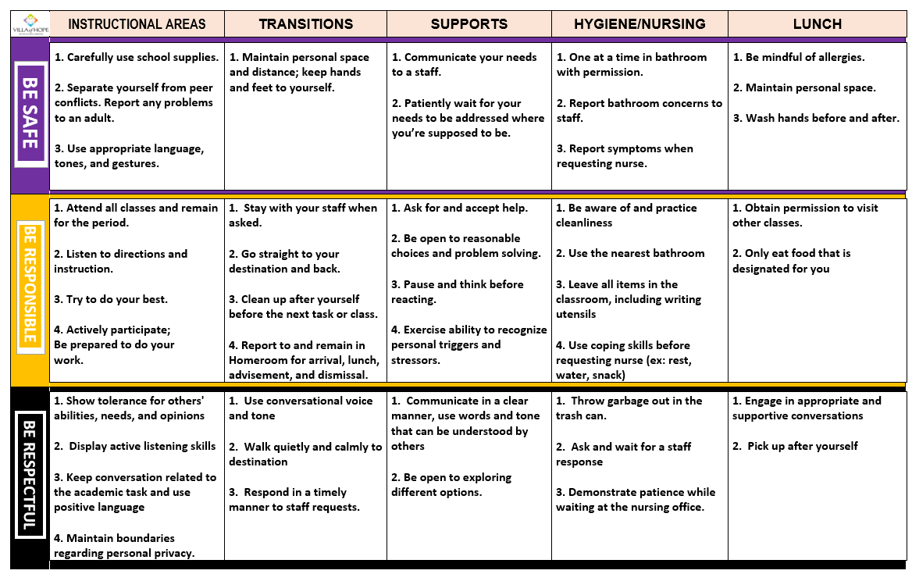

APPENDIX B
Villa of Hope School
Dress Code 2026-2027
The staff at Villa of Hope School desire that all students develop a sense of pride in themselves. The way a student dresses should reflect the thoughts and language of a self-respecting young adult and respect for others. We support students in expressing their individuality appropriately and comfortably to display a positive image.
We ask that parental/guardians and residential teams support our youth by clearly communicating our expectations for appropriate dress to our students. If students come to school inappropriately dressed, students may borrow appropriate clothing from the program, or the parent/guardian or residential staff will be contacted to bring appropriate clothing to school.
Administration and/or Leaders have authority to enforce or modify these expectations as needed to ensure health and safety of staff and students.
The following is the standard of dress for students:
- Underwear, including boxers and briefs should be covered.
- Pants/shorts worn on the waist.
- Pants/shorts with rips/holes above the knee need appropriate undergarment worn underneath.
- Leggings cannot be see through.
- Hats and Beanies are allowed. Hoods permitted, untied.
- Shorts, skirts, and dresses should generally reach the mid-thigh. However, minor variations in length are acceptable as long as the garment fully and securely covers the buttocks and all undergarments at all times (including when walking, sitting, or bending over).
- Footwear to always be worn; footwear covering toes and foot only, backless shoes must have a strap including crocs (worn in sports mode), heels only up to two (2 inches), slippers with rubber soles are allowed.
- Low cut and/or see through garments are not appropriate for school. Sleeveless tops are allowed if the strap at the shoulder is two fingers wide. All shirts need to cover waist. Undergarments should be covered.
- Clothing and accessories can be worn with appropriate and approved logos/designs.
- Cold weather coats and/or jackets need to remain in the homeroom upon arrival and can be picked up and worn at dismissal time.

OTHER:
- Blankets and Stuffed Animals/Other in school are not permitted. When an item arrives at school, it will be stored in a separate location and be bagged/labeled. They will not be accessible throughout the day. Items will be returned at dismissal.
- Open container drinks need to be discarded before transition to Homeroom (HR) or class. Closed containers can be consumed at lunch/mealtime, approved by HR Teacher. All High Energy drinks are NOT allowed at school.
- Any consumable foods, candy, other, should not be for distribution without consent of Parent and Administration. Personal lunch items are allowed. All lunch items need to be ready to eat and can be refrigerated. Warming of any food items are restricted.
- No electronic devices will be permitted (phones, mp3, watches, gaming devices, etc.). Devices used for safety plans are provided by the school.
- Any medical reasons for dress code alterations will be navigated through nursing.
- All clothing closet needs, to go through Nursing, Social Worker, Behavior Support, and/or Administration.
- No bags permitted. When a bag is brought to school it will be locked in homeroom until the end of the day. Students will not have access to their items until dismissal.

APPENDIX C
Student Technology & Device Acceptable Use Agreement
This agreement is entered into between Villa of Hope School, the Student, and the Parent(s)/Guardian(s) to govern the usage of school-issued devices (desktops, laptops, tablets) and confirm acceptance of the Acceptable Use Agreement.
To access and maintain privileges to a school-issued device, students must comply with all school policies, the Code of Conduct, and the guidelines below. Violations may result in the loss of technology privileges and/or disciplinary action.
Student Expectations & Device Care
Students agree to NOT:
- Disrupt the educational process through non-educational use.
- Endanger the health or safety of themselves or others.
- Invade the rights and privacy of others, or engage in illegal/prohibited conduct.
- Download, install, or replace any software, apps, media, or data.
Device Maintenance & Daily Use:
- Handle the device carefully; insert and remove cords/cables gently.
- Do not write, draw, or apply stickers/labels to the device.
- Do not take the device outside. Keep and return the device to the teacher-designated location daily.
Privacy & School Oversight
- No Right to Privacy: School-issued devices and connected cloud accounts are school property. The school reserves the right to examine and search device contents at any time, for any reason.
- Microsoft Teams: Villa of Hope School utilizes Microsoft Teams for assignments, communication, and device login. Additional details are available in the Code of Conduct and Family Handbook.
Damage, Repairs, & Liability
- Hardware Issues: Students must notify the teacher immediately of any functionality or hardware problems. Students must never attempt to fix hardware or operating system faults themselves.
- Accidental Damage: Evaluated on a case-by-case basis. No disciplinary action will be taken for genuine accidents.
- Non-Accidental Damage: Parents/Guardians will be notified of actual repair costs but will not be billed. For damage costs totaling $500 and above, the student will not be permitted to attend events/activities that are funded by Villa of Hope School. Student will be able to attend routine activities (ex: clubs, assemblies). Financial liability is at the sole discretion of the Agency, up to the full replacement value of the device.
- Acknowledgment & Signatures
By signing below, you acknowledge that you have read, understand, and agree to follow all responsibilities and waivers outlined in this Agreement.

Student Name (Printed): ___________________________________________ Date: _____
Student Signature: _____________________________________________________________
Parent/Guardian Name (Printed): ___________________________________ Date: _____
Parent/Guardian Signature: _____________________________________________________
Please return this page to your child’s school

